**Report on File System Assignment (extra credit):**

1. Program features a basic in-memory filesystem with functions such as fs_read and fs_write which are used to read nad write into the newly created file(s) using the fs_create function.
2. Output of the program:

The output of the program is as follows:

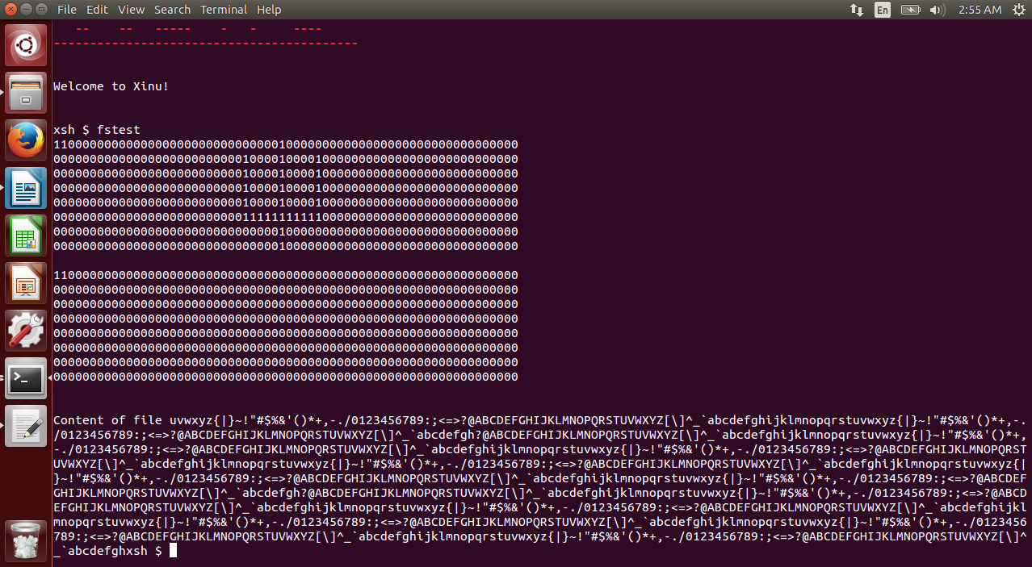

The IU logo is printed on the screen along with the buffer contents read from the file just written into.

Functions used:

Shree:

int fs_seek(int fd, int offset);

int fs_read(int fd, void *buf, int nbytes);

int fs_write(int fd, void *buf, int nbytes);

Saurabh:

int fs_open(char *filename, int flags);

int fs_close(int fd);

int fs_create(char *filename, int mode);

Discussed with **Pruthvi (shettypr)** about the general implementation strategy.